Work to eradicate public health issues
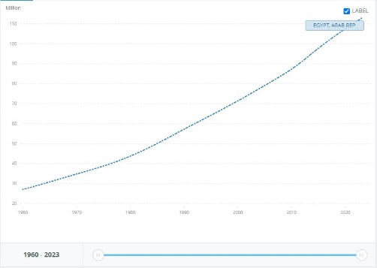
Infectious diseases are the world’s leading cause of morbidity and mortality, according to a report by the WHO at a global level, 7 of the 10 leading causes of deaths in 2021 were noncommunicable diseases, accounting for 38% of all deaths, or 68% of the top 10 causes. And the vector-borne diseases caused by pathogens and parasites in human populations and account for more than 17% of all infectious diseases. Rapid population growth such as in the case of Egypt, which has recently reached a population of 105,914,499 capita in only 5% of the country’s surface area, as shown in figure 1 multiplies the infection rates due to overcrowding and urban congestion. Behind these are factors like: Poverty, Availability of health sectors and personal hygiene. Impacts of these health issues are economic burden and health sector overload, in addition to social and demographic changes.
Figure 1 population growth in Egypt

Causes of Public Health Issues
1.Low-Income
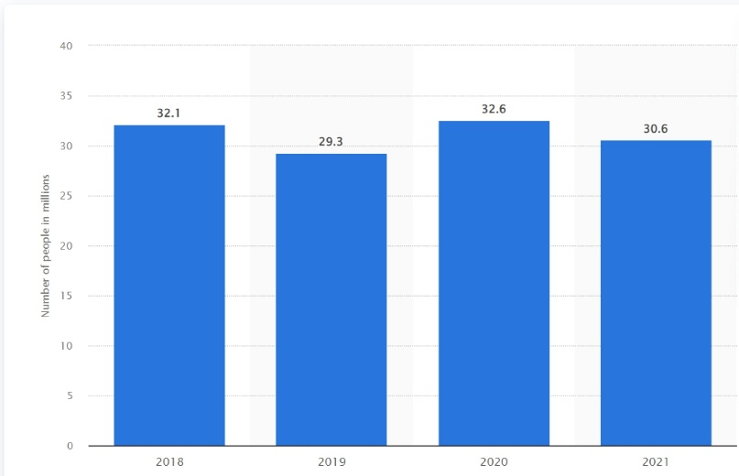
Income affects the public health sector, the leading cause of death for people living in a low-income country is communicable diseases as 8 of the top 10 causes of death in 2021 in low-income countries were communicable diseases. Poverty affects access to medicine and health services, which affects a country with a poverty percentage of 30.6% as of 2021 as shown in figure 2. Furthermore, chronic diseases due to genetic code are harder to fully eliminate and require genetic technology like Gene Therapy, which is limited and highly expensive as in 2021, there were only 15 approved gene therapy products. Access to approved therapies remained limited in LMICs and is exclusively through managed access and compassionate programs.
Figure 2
NO. of people living under the poverty line in Egypt from 2018 to 2021
2-Accessibility to public health.
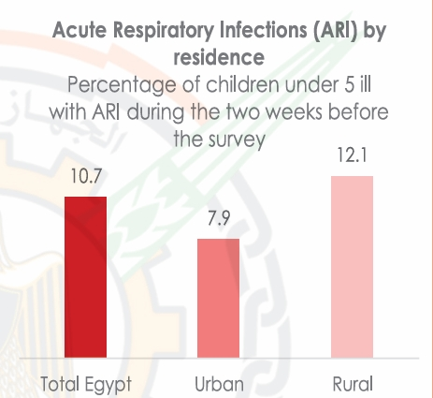
Public health accessibility’s another factor controlling spread of infectious diseases. Egypt has the largest population in north Africa with a population of 105,914,499 capita as of 2024. This makes up 1.3% of the world’s population, congested along the Nile banks and delta which only makes up 5% of Egypt’s surface area of approximately 1 million square kilometers. As a result, 95% of Egyptians live in 5% of the country. This urban congestion increases diseases, especially acute respiratory infections as shown in figure 3.
Figure 3 Acute Respiratory Infections (ARI) by residence
3.Personal Hygiene
In 2014 around 91 percent of the Egyptian population received had access to water in their houses. However, a significant number of households are still not connected with the water system in rural areas and in urban slums. 7.3 million people are deprived of access to safe water, among which 5.8 million live in rural areas and 1.5 million in urban areas. In rural areas, around 12 percent of the population live in dwellings not connected to the water system while, in urban areas, it’s 4 percent which do not have water connection. They are usually located in urban slums and poor settlements. Such individuals don’t have access to clean water needed for personal hygiene which increases infections and public health issues.
Impacts of public health issues
1.Economic Burden
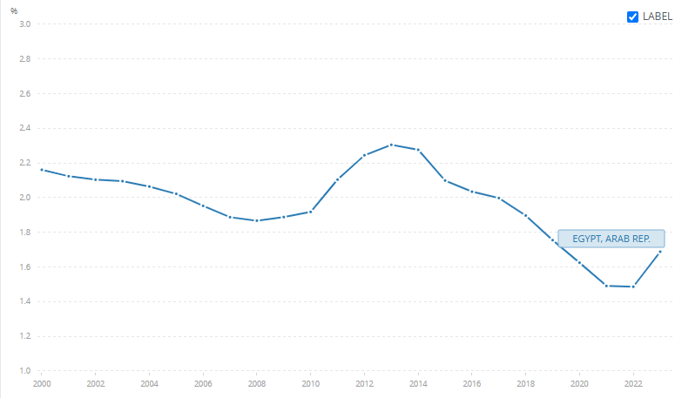
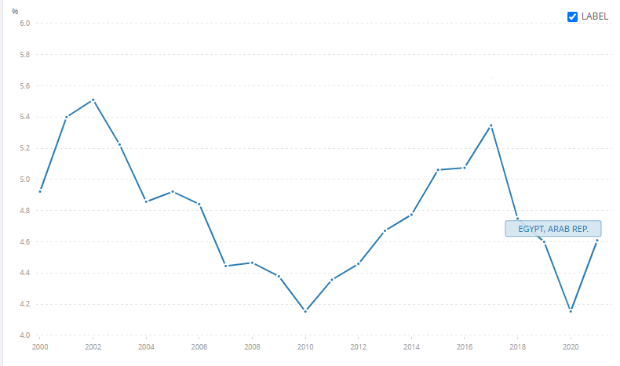
Health issues, disease outbreaks and chronic diseases increase the burden on the healthcare spending of the state. Egypt’s health expenditure reached 4.61% of GDP in 2021, reaching a maximum of 5.51% in 2001 and 5.31% in 2017 as shown in figure 4. The government spending on health has reached this percentage due to disease outbreaks and the increasing healthcare requirements due to the increasing population as Egypt has a population growth rate of 1.7% (as of 2023) as shown in figure 5 and population went from 27M to 112M in 63years with 414% increase in population as shown in figure 6. The increasing population ultimately caused healthcare prices to raise significantly as shown in figures 4 and 5. As disease outbreaks and health issues cause serious damage in highly populated and congested areas.
Figure 5 Population growth (annual %) - Egypt, Arab Rep.
Figure 4 Egypt’s health expenditure in % of gdp, source: World Health Organization Global Health Expenditure database ( apps.who.int/nha/database )
2.Overload on public health sectors
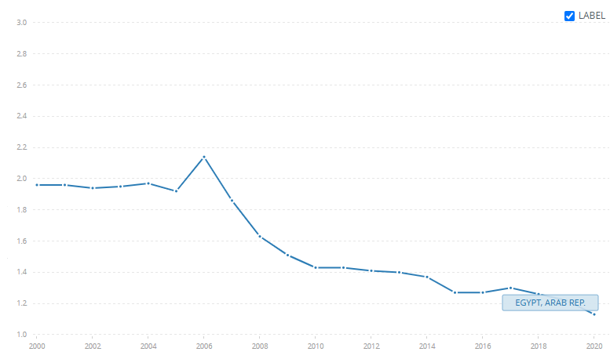
Overcrowding and population congestion has been an issue in Egypt since the mid-20th century. Egypt has grown from 22 in 1950 million to 104 million in 2024. This resulted in multiple other problems, one of which is overload on public health services. Public health services in Egypt can be divided into public hospitals, vaccination programs and local medical centers. These public services are overloaded and cannot provide support for all individuals due to urban congestion and population growth. This can be seen, for example, in the Cairo Metropolitan Area, which has a population density of 40,000 people per square kilometer: up to 100,000/sq km in older districts and a population of 20 million people, which makes up 20% of Egypt’s total population. This area has 0∙23 health facility per 10000 population and 1.4 governmental hospital beds per 1000 people as of 2014 as shown in figure 6. This high population density, insufficient number of healthcare centers and number of hospital beds ultimately lead to overloading the public health sectors.
Figure 6 Hospital beds (per 1,000 people) - Egypt, Arab Rep.
3.Social and demographic changes.
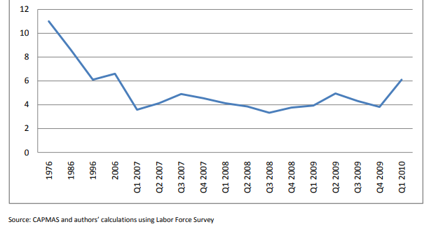
Disease outbreaks in rural areas of Egypt where there is a lack of government and health services encourages the rural population to move to the cities to escape the disease outbreak and utilize the more abundant health care infrastructure in the city. As a result, in addition to other factors like lack of services and lack of job opportunities, internal migration reached 4% between 2007 and 2009 and increased to 6.1 percent in Q1 2010, which can be seen in figure 7. This leads to more pressure and overload on the healthcare system there and leads to more disease outbreaks across the country.
Figure 7 Internal migration rate in Egypt

